**Batch:** B12-6A2E **Technology track:** Internet of things(IoT)

**ASSIGNMENT 1**

**Tinkercad Link:**

<https://www.tinkercad.com/things/f4nBVDRIjX7?sharecode=BUJZPzmA4hbwOl5XH_Bf6JXG5_N3AvZIPsQRZVqsAQk>

**Screen shots:**

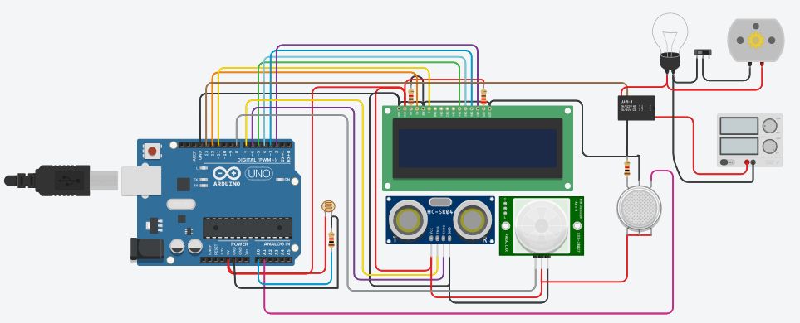

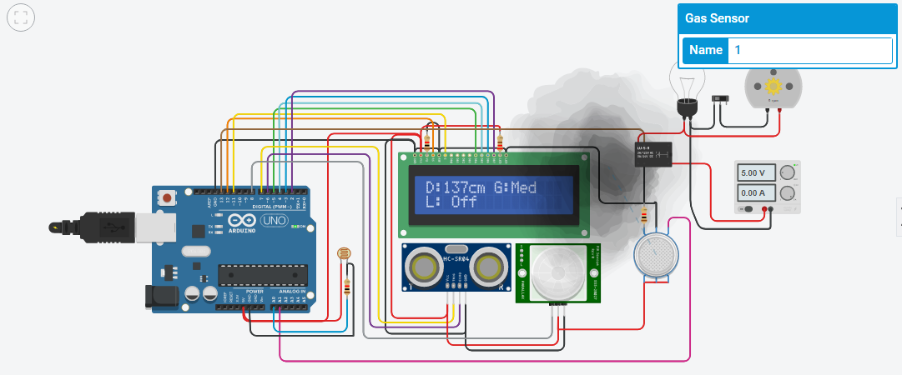

**Code:**

// include the library code:

#include <LiquidCrystal.h>

// initialize the library with the numbers of the interface pins

LiquidCrystal lcd(12, 11, 5, 4, 3, 2);

//For ultrasound sensor

int distanceThreshold = 0;

int cm = 0;

int inches = 0;

//for Relay Control

int releNO = 13;

int inputPir = 8;

int val = 0;

int resuldoSensorLDR;

int sensorLDR = A0;

//For Gas sensor

int const PINO_SGAS = A1;

long readUltrasonicDistance(int triggerPin, int echoPin)

{

pinMode(triggerPin, OUTPUT); // Clear the trigger

digitalWrite(triggerPin, LOW);

delayMicroseconds(2);

// Sets the trigger pin to HIGH state for 10 microseconds

digitalWrite(triggerPin, HIGH);

delayMicroseconds(10);

digitalWrite(triggerPin, LOW);

pinMode(echoPin, INPUT);

// Reads the echo pin, and returns the sound wave travel time in microseconds

return pulseIn(echoPin, HIGH);

}

void setup() {

// set up the LCD's number of columns and rows:

lcd.begin(16, 2);

pinMode(releNO, OUTPUT);

pinMode(inputPir, INPUT);

pinMode(sensorLDR, INPUT);

Serial.begin(9600);

}

void loop() {

// set threshold distance to activate LEDs

distanceThreshold = 350;

// measure the ping time in cm

cm = 0.01723 * readUltrasonicDistance(7, 6);

// convert to inches by dividing by 2.54

inches = (cm / 2.54);

lcd.setCursor(0,0); // Sets the location at which subsequent text written to the LCD will be displayed

lcd.print("D:"); // Prints string "Distance" on the LCD

lcd.print(cm); // Prints the distance value from the sensor

lcd.print("cm");

delay(10);

val = digitalRead(inputPir);

resuldoSensorLDR = analogRead(sensorLDR);

if(resuldoSensorLDR<600)

{

if(val == HIGH)

{

digitalWrite(releNO, HIGH);

lcd.setCursor(0,1);

lcd.print("L: On ");

delay(5000);

}

else{

digitalWrite(releNO, LOW);lcd.setCursor(0,1);

lcd.print("L: Off");

delay(300);

}

}

else{ digitalWrite (releNO, LOW);

Serial.println(resuldoSensorLDR);

delay(500);

}

int color = analogRead(PINO_SGAS);

lcd.setCursor(8,0);

//lcd.print("");

if(color <= 85){

lcd.print("G:Low ");

} else if(color <= 120){

lcd.print("G:Med ");

} else if(color <= 200){

lcd.print("G:High");

} else if(color <= 300){

lcd.print("G:Ext ");

}

delay(250);

}